YUVA INTERNSHIP
Junior Data Analyst – Agribusiness
Task 6 : Agribusiness Operation

INTRODUCTION

Tomato farming in Telangana, while vital to rural livelihoods and regional food supply, faces persistent challenges. Farmers contend with unpredictable market prices, limited access to postharvest infrastructure, and significant crop losses due to spoilage and inefficient logistics. These issues not only reduce income stability but also discourage long-term investment in tomato cultivation.
The proposed cold chain infrastructure—comprising cold storage units, refrigerated transport, and rural collection centers—represents a transformative opportunity. By preserving crop quality, enabling access to premium markets, and streamlining aggregation and distribution, it can reshape the tomato value chain. However, for this solution to be truly effective, its sustainability must be rigorously evaluated across three key dimensions:

1. Environmental Sustainability
Cold chain systems, if poorly designed, can contribute to energy overuse and carbon emissions. A responsible approach must consider:
- Energy efficiency: Use of solar-assisted or hybrid power systems to reduce dependence on fossil fuels
- Refrigerant management: Adoption of low-impact refrigerants and proper disposal protocols to minimize ozone depletion and greenhouse gas emissions
- Waste reduction: Improved packaging and handling practices to reduce spoilage and organic waste at collection centers
- Water usage: Efficient cleaning and cooling systems that minimize water consumption in storage and transport operations
Integrating green technologies and circular practices will help ensure that the infrastructure supports—not harms—the local environment.

2. Economic Sustainability
For the cold chain to thrive, it must be financially viable for all stakeholders involved. Key considerations include:
- Cost recovery models: Affordable user fees for farmers, coupled with cooperative ownership or public-private partnerships to spread capital costs
- Revenue generation: Value-added services such as grading, packaging, and direct-to-market sales that increase farmer earnings
- Operational efficiency: Route optimization, storage utilization, and digital inventory tracking to reduce overhead and improve margins
- Market linkage: Building relationships with institutional buyers, retailers, and processors to ensure consistent demand and fair pricing
A sustainable economic model ensures that the system doesn’t rely indefinitely on subsidies, but becomes self-sustaining through smart design and inclusive business models.

3. Social Sustainability
Beyond infrastructure and economics, the cold chain must empower communities and promote equity. This includes:
- Farmer inclusion: Ensuring that smallholder farmers—especially women and marginalized groups—have access to infrastructure, training, and decision-making
- Capacity building: Ongoing education on postharvest handling, cold storage usage, and market negotiation to build local expertise
- Job creation: Generating employment in logistics, maintenance, and collection center operations, with fair wages and safe working conditions
- Community ownership: Encouraging cooperative models or local governance structures that give stakeholders a voice in how the system evolves
Social sustainability ensures that the benefits of the cold chain are widely shared and that the system strengthens—not replaces—local agency and resilience.

Environmental Impact of Cold Chain Infrastructure in Tomato Farming

Key Challenges
The integration of cold chain infrastructure into tomato farming in Telangana presents a complex set of environmental challenges that must be addressed to ensure long-term sustainability. These challenges are particularly pronounced in rural and semi-urban areas where infrastructure gaps and resource constraints intersect with climate vulnerabilities.
1. Energy Consumption in Cold Storage Units Most conventional cold storage facilities rely on grid electricity or diesel generators, both of which are environmentally taxing. In regions with unreliable power supply, diesel becomes the default backup, leading to high operational costs and increased carbon emissions. This dependence on non-renewable energy sources undermines the environmental benefits of postharvest preservation.
2. Emissions from Refrigerated Transport The use of diesel-powered vehicles for transporting perishable produce contributes significantly to greenhouse gas emissions. These vehicles often operate inefficiently due to poor road conditions, fragmented supply chains, and lack of route optimization, further compounding their environmental footprint.
3. Water Usage in Farming and Cooling Systems Tomato cultivation is water-intensive, and when combined with the water demands of cooling systems in storage and transport, the pressure on local water resources becomes substantial. In areas already facing seasonal water scarcity, this can lead to unsustainable extraction and long-term ecological degradation.
4. Waste Generation from Spoiled Produce Due to delays in transportation, lack of timely access to cold storage, and inefficient handling, a significant portion of harvested tomatoes is lost postharvest. This not only represents a loss of income but also contributes to organic waste accumulation. When disposed of improperly, spoiled produce generates methane—a potent greenhouse gas—and adds to landfill burden.

Strategic Interventions for Environmental Sustainability
To address these challenges, a combination of technological innovation, decentralized infrastructure, and resource-efficient practices can be deployed. These strategies aim to reduce environmental impact while enhancing the resilience and efficiency of the tomato supply chain.
1. Transition to Solar-Powered Cold Storage Solar-powered cold storage units offer a clean and reliable alternative to diesel-based systems. Innovations such as thermal energy backup and smart temperature control (e.g., Ecofrost, Tan90) allow for consistent cooling even during power outages. These units can be deployed at the farm gate or in rural aggregation centers, reducing spoilage and energy costs. Models like Cooling-as-a-Service (CaaS) enable farmers to pay only for usage, making the technology more accessible and scalable.
2. Adoption of Electric and Hybrid Transport Solutions Replacing diesel trucks with electric or hybrid refrigerated vehicles can significantly reduce emissions, especially for short-haul routes between farms and collection centers. Nigeria’s recent success in piloting solar-powered cold transport demonstrates the feasibility of such models in resource-constrained settings. Integration of IoT and GPS tracking further enhances route efficiency and reduces fuel consumption.
3. Water Conservation in Cultivation and Cooling Implementing rainwater harvesting and drip irrigation systems in tomato farms can drastically reduce water usage while improving crop yield. In cold storage facilities, closed-loop water recycling systems and low-water cleaning technologies can minimize consumption without compromising hygiene standards. These practices are particularly critical in drought-prone districts of Telangana.
4. Organic Waste Management and Composting Spoiled tomatoes and other organic waste can be composted at collection centers to produce nutrient-rich soil amendments, supporting circular agriculture. In larger facilities, biogas digesters can convert waste into clean energy, reducing methane emissions and providing an alternative power source for cooling operations. These solutions not only reduce landfill burden but also create value from waste.

Broader Environmental Implications
By implementing these strategies, cold chain infrastructure in Telangana can evolve into a climate-smart system that supports both agricultural productivity and ecological balance. Key benefits include:
- Reduction in carbon emissions and air pollutants
- Conservation of water and energy resources
- Enhanced soil health through composting and organic recycling
- Improved resilience to climate variability and resource scarcity
- Alignment with India’s national goals for sustainable agriculture and rural electrification

Economic Impact

Key Issues in Tomato Supply Chain Management
1. High Capital Investment and Delayed ROI for Infrastructure Setup Cold chain infrastructure—such as refrigerated transport, pre-cooling units, and storage hubs—requires significant upfront investment. For smallholder-focused systems, the return on investment (ROI) is often delayed due to seasonal demand, underutilization, and fragmented supply chains. This financial strain discourages private investment and limits scalability.
2. Price Volatility in Tomato Markets Affecting Profitability Tomatoes are highly perishable and subject to seasonal gluts. During peak harvest, prices can crash dramatically, leaving farmers unable to recover input costs. Without price stabilization mechanisms, even well-managed farms face unpredictable income, undermining long-term planning and investment.
3. Limited Access to Credit for Smallholder Farmers Most small-scale farmers lack formal credit histories or collateral, making it difficult to access loans for inputs, packaging, or transport. This financial exclusion prevents them from participating in value-added supply chains or investing in postharvest infrastructure.
4. Logistical Inefficiencies Increasing Operational Costs Poor road connectivity, lack of route planning, and fragmented transport networks lead to delays, fuel wastage, and spoilage. These inefficiencies inflate operational costs and reduce the competitiveness of rural produce in urban markets.

Improvement Strategies for Economic and Operational Viability

1. Leverage Government Subsidies and Public-Private Partnerships (PPPs) India offers robust financial support for cold chain development through schemes like:
- Pradhan Mantri Kisan SAMPADA Yojana (PMKSY): Grants up to ₹10 crore for integrated cold chain projects, including storage, transport, and processing.
- Mission for Integrated Development of Horticulture (MIDH): Offers 35–50% subsidies for energy-efficient cold storage units.
- National Horticulture Board (NHB): Provides capital investment subsidies for storage hubs between 5,000–10,000 MT.
By combining these subsidies with PPP models, infrastructure costs can be shared between government bodies, agribusiness firms, and farmer cooperatives—reducing financial risk and accelerating deployment.
2. Establish Contract Farming and Digital Marketplaces to Stabilize Prices Contract farming offers pre-agreed prices, guaranteed buyers, and access to inputs and training. For example, PRAN’s tomato contract farming model in Bangladesh helped over 10,000 farmers stabilize incomes and reduce postharvest losses. Benefits include:
- Reduced price risk and market uncertainty
- Access to technical support and quality inputs
- Flexibility to sell in open markets when prices are favorable5
Digital platforms further enhance market access by connecting farmers directly with buyers, enabling price transparency and reducing dependency on middlemen.
3. Offer Microfinance and Crop Insurance to Reduce Financial Risk Microfinance institutions (MFIs) empower farmers by offering small loans for inputs, packaging, and transport. Tailored products—like group-based savings schemes or seasonal repayment plans—accommodate the cash flow cycles of tomato farming. Crop insurance schemes such as the Pradhan Mantri Fasal Bima Yojana (PMFBY) protect farmers from weather-related losses and market disruptions. PMFBY currently covers over 41 million farmers and 62 million hectares, offering affordable protection against droughts, floods, and unseasonal rainfall.
4. Use Route Optimization Software to Reduce Fuel Costs and Delays Modern logistics software—such as Track-POD, Esri’s ArcGIS Navigator, and ClickPost—can optimize delivery routes based on traffic, fuel usage, and delivery windows9. Benefits include:
- Shorter delivery times and reduced spoilage
- Lower fuel costs and better fleet utilization
- Real-time tracking and improved coordination with buyers

SOCIAL IMPACT
- Low farmer participation due to lack of awareness or trust
Many farmers remain hesitant to adopt new technologies or participate in programs because they are unaware of the benefits or skeptical of promised outcomes. In some cases, past experiences with poorly implemented initiatives have further reduced trust.

- Labor safety concerns in handling cold storage and transport
Workers involved in cold chain operations often face long hours in low-temperature environments without proper safety gear, leading to health risks such as frostbite, respiratory issues, and fatigue.

- Limited community engagement in infrastructure planning
Infrastructure projects, like cold storage or transport facilities, are sometimes planned without consulting the local community. This leads to mismatched priorities, underutilized facilities, and resentment toward project implementers.

- Gender disparities in access to resources and training
Women farmers, who make up a significant portion of the agricultural workforce, often face barriers in accessing financial resources, equipment, or skill development programs due to social norms and unequal opportunity structures.

Improvement Strategies
- Conduct awareness campaigns and pilot programs to build trust
Organize village-level workshops, demonstration farms, and success story showcases where early adopters share their experiences. Using local languages, relatable examples, and respected community figures can help break skepticism and encourage participation.

- Ensure fair labor practices, safety training, and protective equipment
Develop mandatory safety protocols for all cold storage and transportation operations. Provide high-quality insulated clothing, gloves, and safety footwear to all workers. Regular safety drills and health check-ups can reinforce a culture of care.

- Involve local communities in decision-making and feedback loops
Set up community committees that include farmers, transporters, traders, and local leaders to participate in infrastructure planning. Conduct feedback sessions after implementation to continuously improve services and ensure facilities meet actual needs.

- Promote women-led cooperatives and inclusive training programs
Create special funding schemes, mentorship networks, and skill-building programs tailored for women. Encourage women’s leadership in producer groups, ensuring they have equal say in financial and operational decisions. Highlight role models from the community to inspire broader participation.

Integrated Sustainability Strategy
Based on the sustainability audit, the following integrated strategy is proposed:

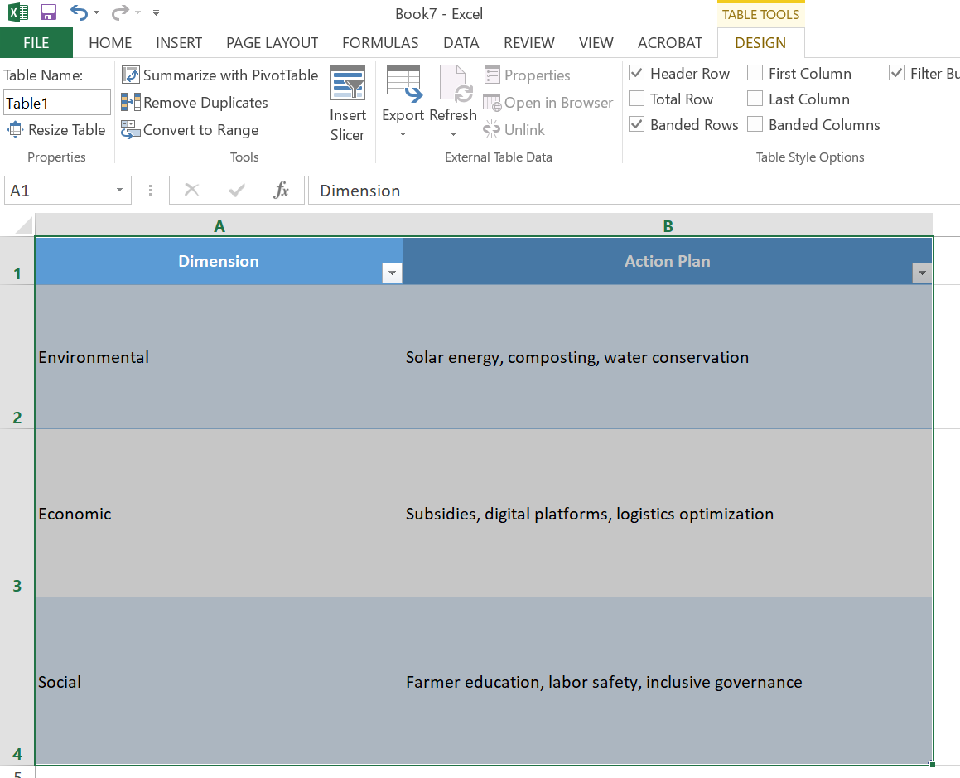

Conclusion

The sustainability of tomato cold chain infrastructure in Telangana depends on harmonizing environmental stewardship, economic viability, and social inclusion. Cold chain systems have the potential to drastically reduce post-harvest losses, increase farmer incomes, and deliver fresher produce to consumers, but only if designed and managed with long-term responsibility in mind.
By integrating smart technologies such as IoT-based temperature monitoring, solar-powered refrigeration, and AI-driven logistics planning, stakeholders can optimize operations while minimizing energy consumption and carbon emissions. Likewise, adopting inclusive policies ensures that smallholder farmers, women producers, and marginalized communities are not just beneficiaries but active participants in the value chain.
Efficient resource management—from water and energy conservation to the reuse of packaging materials—can further enhance both environmental and financial performance. But beyond infrastructure and technology, the system’s resilience relies on building trust, transparency, and collaboration among all actors, including farmers, cooperatives, transporters, traders, and policymakers.
This assessment outlines a roadmap for sustainable development that can transform Telangana’s tomato supply chain into a model of resilience and fairness. If implemented effectively, it will not only protect the livelihoods of thousands of farmers but also provide consumers with safer, higher-quality produce while safeguarding the planet’s resources. Ultimately, the success of this cold chain infrastructure will be measured not just in profits or production volumes, but in the lasting social and environmental impact it leaves behind.

THANK YOU

